1.
import java.util.Scanner;

class Processor extends Thread {

private volatile boolean running = true;

public void run() {

while(running) {
System.out.println("Running");

try {
Thread.sleep(50);
} catch (InterruptedException e) {

e.printStackTrace();
}
}
}

public void shutdown() {
running = false;
}
}

public class VolatileEx {

public static void main(String[] args) {
Processor pro = new Processor();
pro.start();

// Wait for the enter key
new Scanner(System.in).nextLine();

pro.shutdown();
}

}
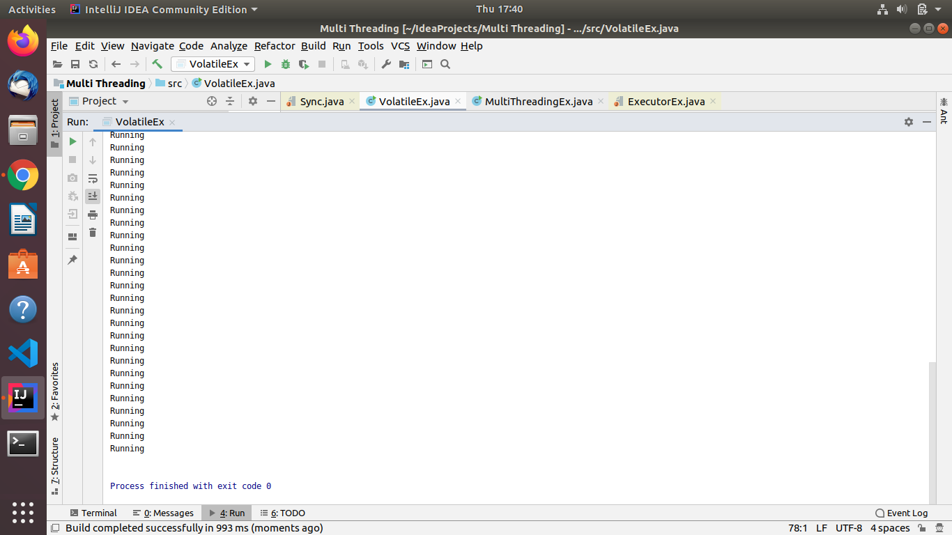

2.
a)Thread class

class ThreadImpl extends Thread{
@Override
public void run () {
super.run();
for (int i= 0;i<10;i++){
System.out.println(i);
try {
sleep(100);
} catch (InterruptedException e) {
e.printStackTrace();
}
}
}
}
public class ThreadEx {
public static void main(String[] args) {
ThreadImpl th = new ThreadImpl();
th.start();
ThreadImpl th1 = new ThreadImpl();
th1.start();
}
}
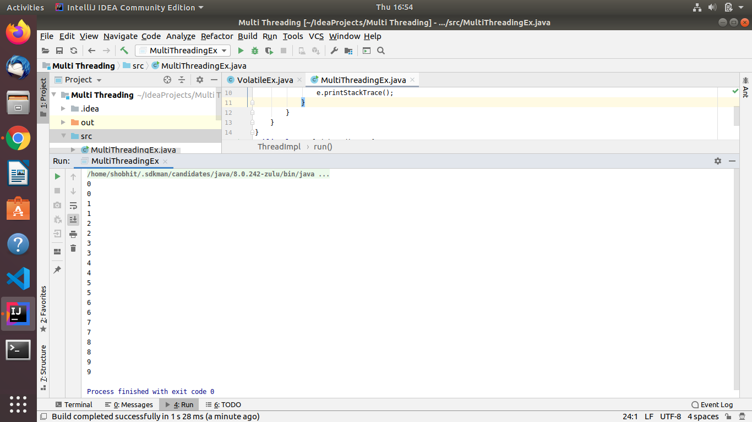

b)Runnable

import static java.lang.Thread.sleep;

class ThreadImp implements Runnable{

@Override
public void run() {
for (int i=0;i<10;i++){
System.out.println(i);
try {
Thread.sleep(100);
} catch (InterruptedException e) {
e.printStackTrace();
}
}
}
}
public class MultiThreadingEx {
public static void main(String[] args) {
Thread th = new Thread(new ThreadImp());
th.start();

}
}
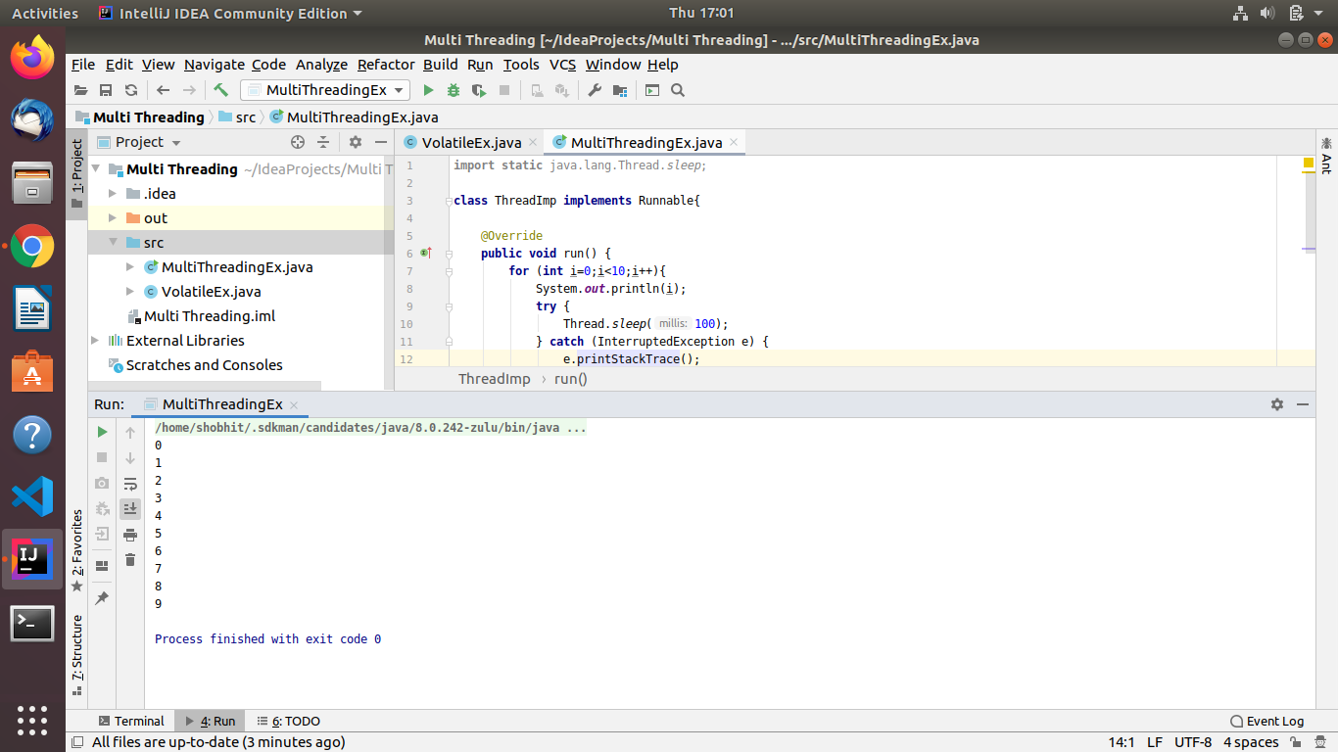

3.
a)synchronized method

public class Sync {
private int count =0;
public synchronized void increment(){
count++;
}
public static void main(String[] args) {
Sync s = new Sync();
s.doWork();
}
public void doWork(){
Thread th = new Thread(new Runnable() {
@Override
public void run() {
for (int i=0;i<10000;i++){
increment();
}
}
});
Thread th1 = new Thread(new Runnable() {
@Override
public void run() {
for (int i=0;i<10000;i++){
increment();
}
}
});
th.start();
th1.start();
try {
th.join();
th1.join();
} catch (InterruptedException e) {
e.printStackTrace();
}

System.out.println(count);
}
}
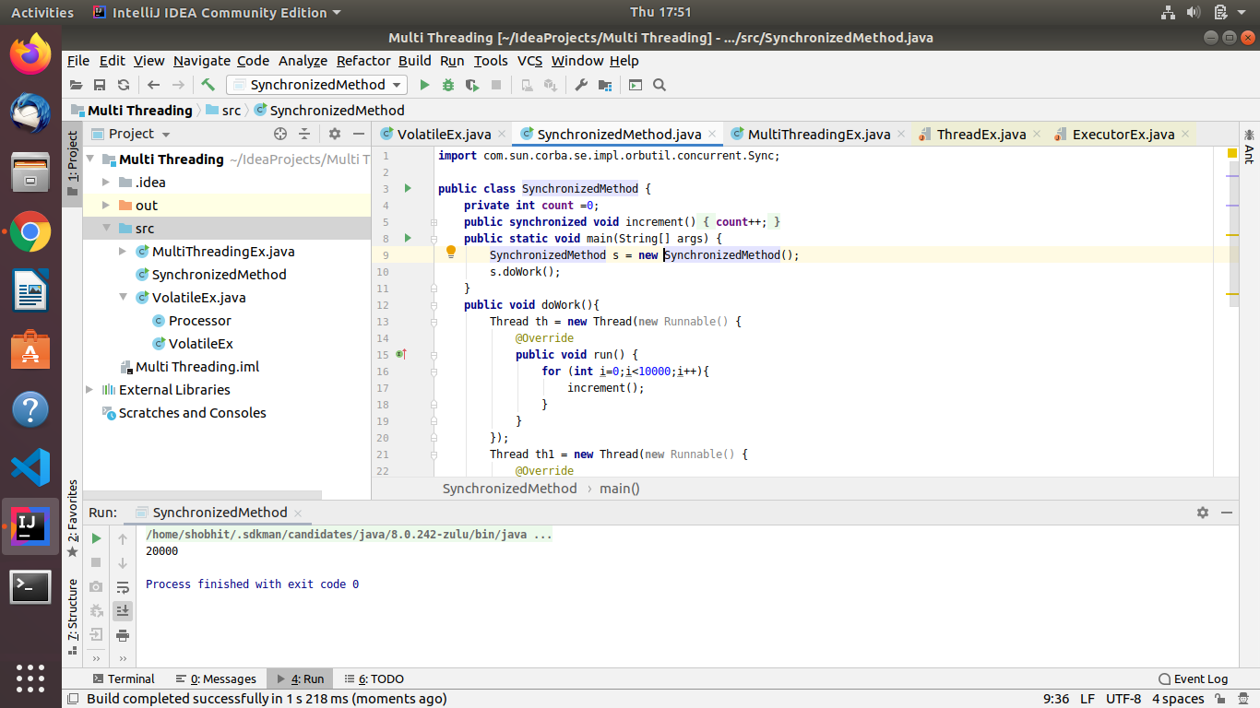

b)synchronized block

class Table{

void printTable(int n){
synchronized(this){
for(int i=1;i<=5;i++){
System.out.println(n*i);
try{
Thread.sleep(400);
}catch(Exception e){System.out.println(e);}
}
}
}
}

class MyThread1 extends Thread{
Table t;
MyThread1(Table t){
this.t=t;
}
public void run(){
t.printTable(5);
}

}
class MyThread2 extends Thread{
Table t;
MyThread2(Table t){
this.t=t;
}
public void run(){
t.printTable(100);
}
}

public class SynchronizedBlock{
public static void main(String args[]){
Table obj = new Table();
MyThread1 t1=new MyThread1(obj);
MyThread2 t2=new MyThread2(obj);
t1.start();
t2.start();
}
}

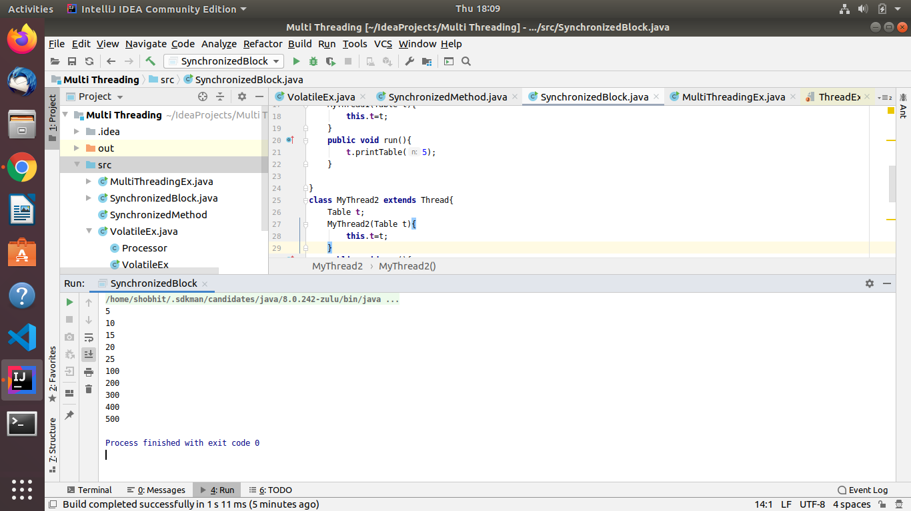

4.
import java.util.concurrent.ExecutorService;
import java.util.concurrent.Executors;
import java.util.concurrent.TimeUnit;

class Processor1 implements Runnable {

private int num;

public Processor1(int num) {
this.num = num;
}

public void run() {
if (num%2!=0)
System.out.println(num);
try {
Thread.sleep(100);
} catch (InterruptedException e) {
}
if (num%2==0)
System.out.println(num);
}
}
public class ThreadPoolEx {

public static void main(String[] args) {

ExecutorService executor = Executors.newFixedThreadPool(2);

for (int i = 0; i < 10; i++) {
executor.submit(new Processor1(i));
}

executor.shutdown();

try {
executor.awaitTermination(1, TimeUnit.DAYS);
} catch (InterruptedException e) {
}
}
}
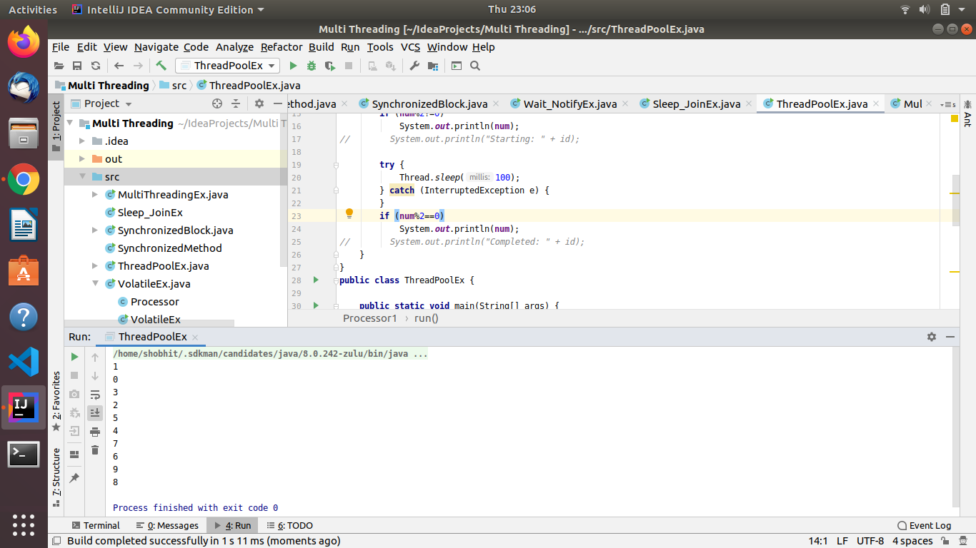

5.
class Customer {
int amount = 10000;

synchronized void withdraw(int amount) {
System.out.println("going to withdraw...");

if (this.amount < amount) {
System.out.println("Less balance; waiting for deposit...");
try {
wait();
} catch (Exception e) {
}
}
this.amount -= amount;
System.out.println("withdraw completed...");
}
synchronized void deposit(int amount) {
System.out.println("going to deposit...");
this.amount += amount;
System.out.println("deposit completed... ");
notify();
}
}
public class Wait_NotifyEx {
public static void main(String args[]) {
Customer c = new Customer();
new Thread() {
public void run() {
c.withdraw(15000);
}
}.start();
new Thread() {
public void run() {
c.deposit(10000);
}
}.start();
}
}
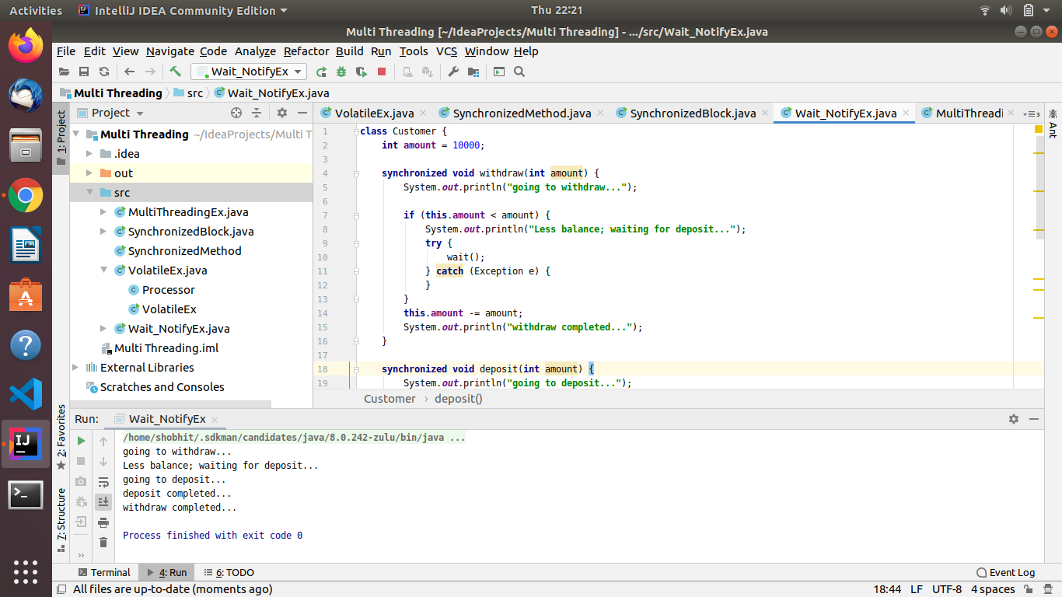

6.
public class Sleep_JoinEx {
private int i = 0;
public static void main(String[] args) {
Sleep_JoinEx sj = new Sleep_JoinEx();
sj.check();
}
public void check() {
Thread t = new Thread(new Runnable() {
@Override
public void run() {
i++;
try {
Thread.sleep(100);
} catch (InterruptedException e) {
e.printStackTrace();
}
}
});
Thread t2 = new Thread(new Runnable() {
@Override
public void run() {
i++;
}
});
t.start();
t2.start();
try {
t.join();
t2.join();
} catch (InterruptedException e) {
e.printStackTrace();
}
System.out.println(i);
}
}

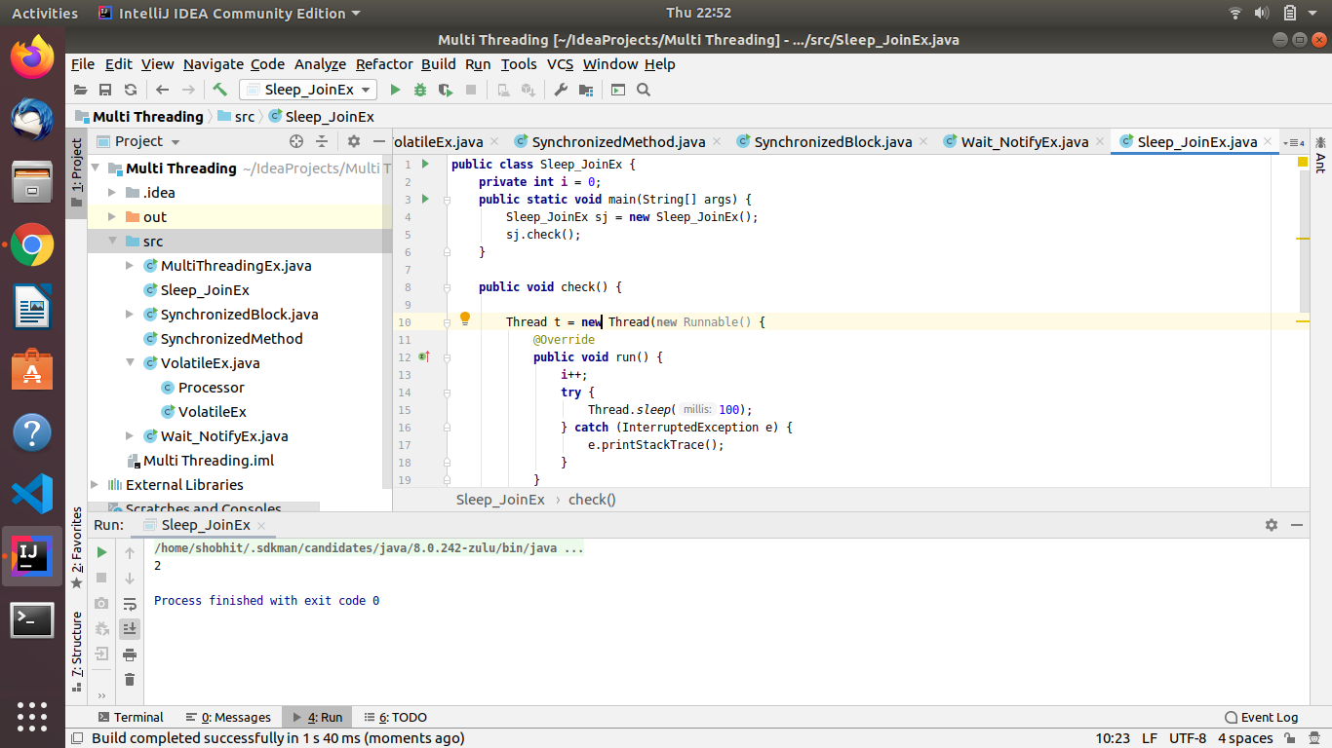

7.
import java.util.Random;
import java.util.concurrent.*;

public class Callable_FutureEx {
public static void main(String[] args) {
ExecutorService ex = Executors.newCachedThreadPool();
Future<Integer> fu = ex.submit(new Callable<Integer>() {
@Override
public Integer call() throws Exception {
Random rand = new Random();
int n = rand.nextInt(10);
n *= n;
return n;
}
});
ex.shutdown();
try {
System.out.println(fu.get());
} catch (InterruptedException e) {
e.printStackTrace();
} catch (ExecutionException e) {
e.printStackTrace();
}
}
}
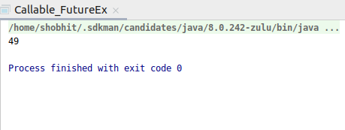

8.
import java.util.concurrent.ExecutorService;
import java.util.concurrent.Executors;
import java.util.concurrent.Semaphore;
import java.util.concurrent.TimeUnit;

class connection{
private Semaphore sem = new Semaphore(2);
private int connections=0;
public void connect() throws InterruptedException {
sem.acquire();
synchronized (this)
{
connections++;
System.out.println("Current connections:"+ connections);
}
Thread.sleep(2000);
synchronized (this)
{
connections--;
}
sem.release();
}
}
public class SemaphoreEx{
public static void main(String[] args) throws Exception{
ExecutorService executor = Executors.newCachedThreadPool();
connection obj = new connection();
for (int i=0;i<10;i++)
{
executor.submit(new Runnable() {
@Override
public void run() {
try {
obj.connect();
} catch (InterruptedException e) {
e.printStackTrace();
}
}
});
}
executor.shutdown();
executor.awaitTermination(1, TimeUnit.DAYS);
}
}
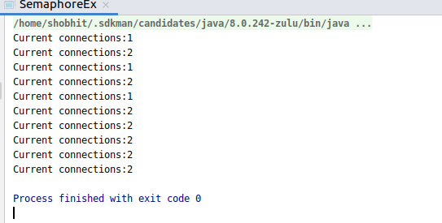

9.
import java.util.concurrent.CountDownLatch;
import java.util.concurrent.ExecutorService;
import java.util.concurrent.Executors;

class Processor2 implements Runnable
{
private CountDownLatch latch;
public Processor2(CountDownLatch latch)
{
this.latch=latch;
}
@Override
public void run() {
System.out.println("Started.");
try {
Thread.sleep(3000);
} catch (InterruptedException ex) {
ex.printStackTrace();
}
latch.countDown();
}
}
public class CountdownLatchEx{
public static void main(String[] args) {
CountDownLatch latch = new CountDownLatch(3);
ExecutorService executor = Executors.newFixedThreadPool(3);
for(int i=0;i<3;i++)
{
executor.submit(new Processor2(latch));
}
try{
latch.await();
}
catch (InterruptedException ex) {
ex.printStackTrace();
}
executor.shutdown();
System.out.println("Completed.........");
}
}

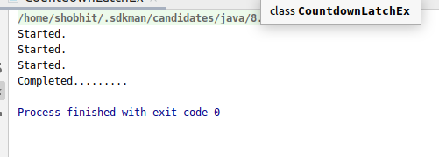

10.
public class DeadlockEx {
public static void main(String[] args) {
final String resource1 = "abc";
final String resource2 = "xyz";
Thread t1 = new Thread() {
public void run() {
synchronized (resource1) {
System.out.println("Thread 1: locked resource 1");
try { Thread.sleep(100);} catch (Exception e) {}
synchronized (resource2) {
System.out.println("Thread 1: locked resource 2");
}
}
}
};
Thread t2 = new Thread() {
public void run() {
synchronized (resource2) {
System.out.println("Thread 2: locked resource 2");
try { Thread.sleep(100);} catch (Exception e) {}
synchronized (resource1) {
System.out.println("Thread 2: locked resource 1");
}
}
}
};t1.start();
t2.start();
}
}
